# **9.2 Guided Exercise: Analysing Policies**

|  |  |
| --- | --- |
| **Resources** | |
| Files | None |
| Machines | Windows 10 |

In this exercise you will use the PolicyAnalyser tool to analyse existing policies and provide recommendations.

Login to Windows 10 and open the Desktop folder Exercises -> PolicyAnalyzer.

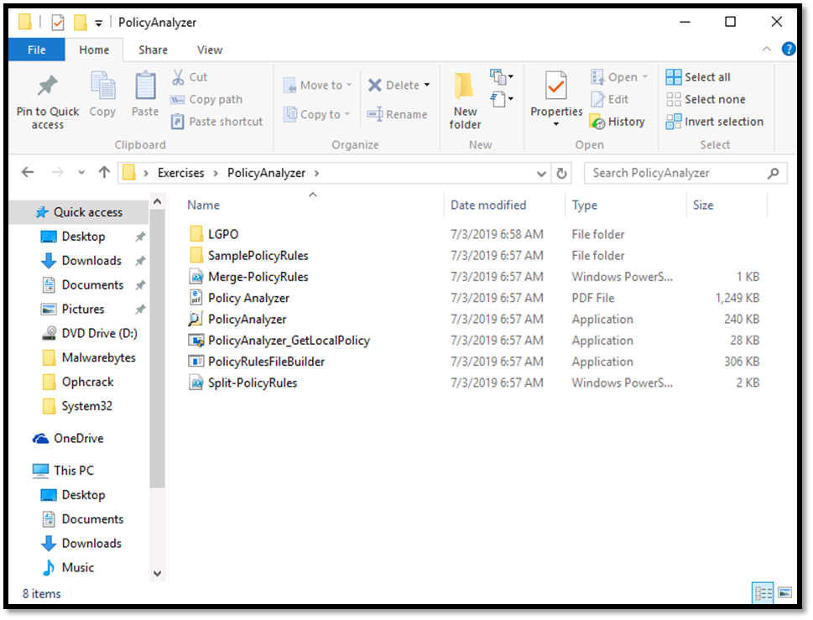

Double click the file PolicyAnalyzer to start it. Click run on the Security Warning window.

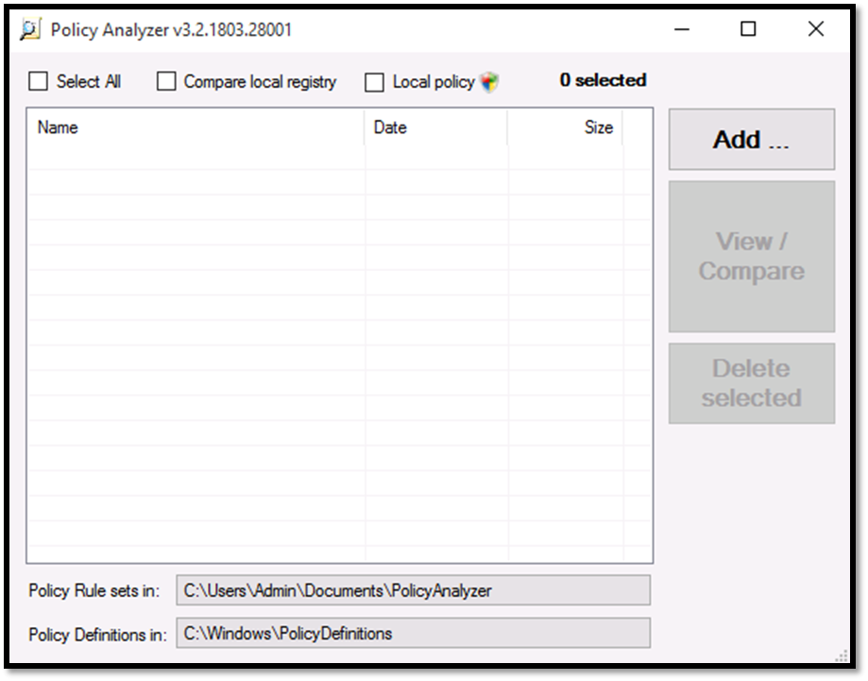

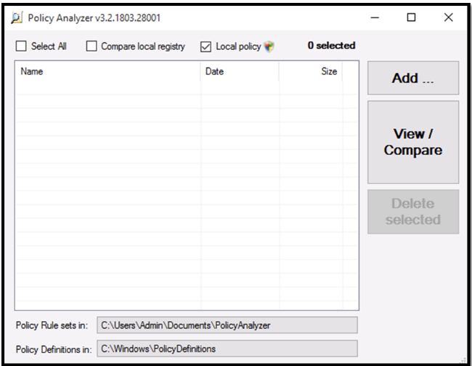Check the box Local Policy and then click on View/Comapre button. Click Yes on the User Account Control Window and click Run on the Security Warning window.

Once the results are shown scroll till you find the Policy Setting for SAM. The Local policy says No Auditing. What will your recommendation be?

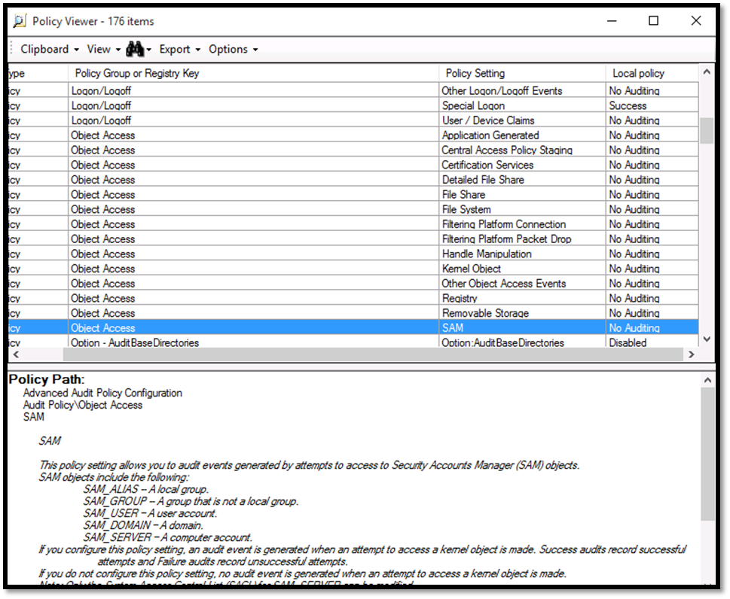

A recommendation will be to audit such object as the SAM file contains the password hashes for the Windows users.